# WorkflowExecuteStep

**Objective:**

It is Used to call another workflow from the workflow under context.

**Attributes:**

|  |  |
| --- | --- |
| **Attributes** | **Description** |
| workflow_id | Used to select the workflow name which we want to execute in current workflow |
| exception_handle | To handle exception or nor and type is boolean, default value is true |

**Sample config.json:**

{

"workflows":[

{

"name":"workflowexecutor",

"id":1828,

"trigger":"rest",

"expression":"/workflowexecutor",

"method":"POST",

"steps":[

{

"type":"start",

"id":1,

"next":{

"start":"2"

}

},

{

"id": "2",

"type": "sql-s3-import",

"workflow_id": "tesge",

"exception_handle": "true",

"next":{

"success": "3",

"failure": "hangup"

}

},

{

"http_response_code":"200",

"response_content_type":"application/json",

"value_type":"hb",

"type":"send",

"id":"3",

"next":{

"success":"hangup",

"failure":"hangup"

}

}

]

}

],

"filters":[],

"server":{

},

"plugins":[]

}

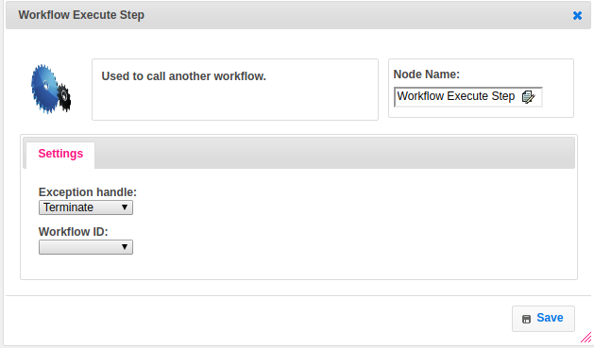

**Executor Description:**

In executor class first will get the workflow name from ObjectRegistry and new step manager is created to pass the complete context of the current workflow. If exception handle is true then it will handle the exception otherwise will terminate.